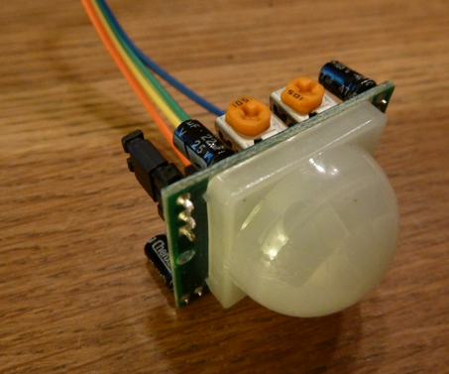
HC-SR501: Left poti is to adjust sensitivity. I have set it to medium. Right poti is to adjust the delay. I set it to minimum which means it triggers about every 5 seconds.
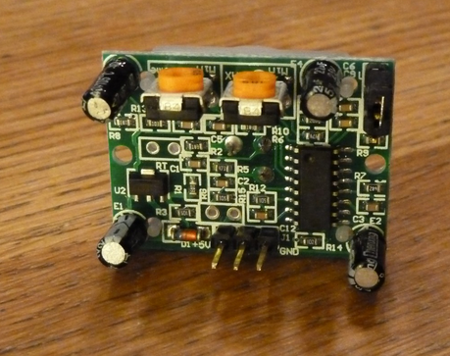
On the bottom are the connections for 5V (left), signal (middle) and GND (right). I tried around with the jumper on the top right, but couldn’t really tell a different behaviour.
I thought the signal pin delivers an analog value according to the distance so I added a LED to pin 11 for the output. This was the initial setup:
#define pir A0
#define led 11
void setup() {
pinMode(pir, INPUT);
pinMode(led, OUTPUT);
Serial.begin(9600);

}
void loop() {
int i = analogRead(pir);
int l = map(i,0,1023,0,255);

Serial.print(i);
Serial.print(" / ");
Serial.println(l);
analogWrite(led, l);

delay(100);
}
I realized that the value I was reading at the sensor pin was always around 680 not matter what.
I then went on to change analogRead to digitalRead:
#define pir A0
#define led 11
void setup() {
pinMode(pir, INPUT);
pinMode(led, OUTPUT);
}
void loop() {
digitalWrite(led, digitalRead(pir));
delay(100);
}

And it worked too… but I think going forward I will use analogRead and will react to motion once the value delivered by the PIR is higher than 500.

